Two-pointer problems
The two-pointer technique is an algorithmic approach in which we use two variables (pointers or indices) to traverse an array or string efficiently.
Instead of using nested loops to examine every pair of elements, we move two pointers according to certain conditions. This can often reduce the time complexity from \(O(n^2)\) to \(O(n)\).
Two pointers are often named left and right, or i and j.

1. Example: Find a pair whose sum equals a target
Suppose the array is sorted:
int arr[] = {1, 2, 4, 6, 8, 9};
int target = 10;
We need to find two numbers whose sum is 10.
Sorted array · Target = 10

1 2 4 6 8 9

L R

Current sum: 10
Compare the sum with the target. If the sum is too small, move left right. If it is too large, move right left.
ResetShow matching pair
The logic is:
- If arr[left] + arr[right] == target, we found the pair.
- If the sum is smaller than the target, move left++ to increase the sum.
- If the sum is larger than the target, move right-- to decrease the sum.
Why does this work? Because the array is sorted. Moving the left pointer rightward selects a larger number; moving the right pointer leftward selects a smaller number.

2. C++ program

#include <iostream>
using namespace std;

int main()
{
int arr[] = {1, 2, 4, 6, 8, 9};
int n = sizeof(arr) / sizeof(arr[0]);
int target = 10;

int left = 0;
int right = n - 1;

while (left < right)
{
int sum = arr[left] + arr[right];

if (sum == target)
{
cout << "Pair found: "
<< arr[left] << " and "
<< arr[right];
return 0;
}
else if (sum < target)
{
left++;
}
else
{
right--;
}
}

cout << "No pair found";
return 0;
}
Output:
Pair found: 1 and 9
Complexity: Time (O(n)), extra space (O(1)).
The important condition is that this approach requires a sorted array to guarantee that moving the pointers in this way will not miss a valid pair. For an unsorted array, you could sort it first, or use hashing instead.

3. Types of two-pointer techniques
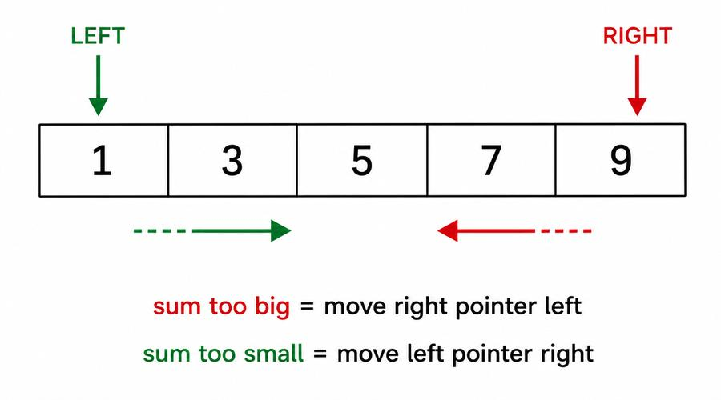
Type 1: Opposite-direction pointers
One pointer starts at the beginning and the other at the end. They move toward each other.
Examples:
- Two Sum in a sorted array
- Reverse an array
- Check whether a string is a palindrome
- Container With Most Water
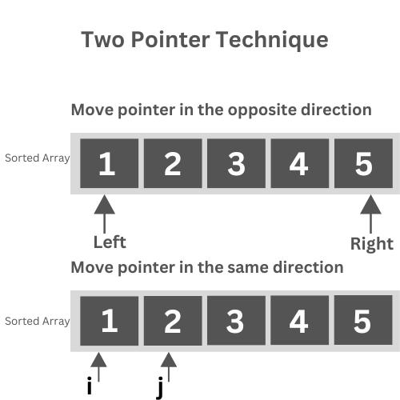
Type 2: Same-direction pointers
Both pointers move from left to right, often at different positions or with different purposes.
Examples:
- Move all zeros to the end
- Remove duplicates from a sorted array
- Merge two sorted arrays
- Find the intersection of two sorted arrays

The two-pointer technique is especially useful for reducing (O(n^2)) solutions to (O(n)) after sorting, or when processing an array in one pass.
No. | Problem | Example / objective
1 | Two Sum in a sorted array | {1, 2, 4, 7, 11}, target 9 → indices of 2, 7
2 | Pair with a given sum | Find two elements whose sum equals a target
3 | Move all zeros to the end | {0, 1, 0, 3} → {1, 3, 0, 0}
4 | Remove duplicates in-place | Sorted array; retain unique values
5 | Reverse an array in-place | Swap elements from both ends
6 | Container With Most Water | Find two heights that maximize the contained area

Hashing
Hashing is a technique used to store and find data quickly using a key.
For example, suppose you have this array:
int arr[] = {2, 3, 2, 5, 3, 2};

You want to count how many times each number occurs.

The frequency is:
Number | Frequency
2 | 3
3 | 2
5 | 1

Instead of searching the entire array repeatedly, we use a hash table to store each number and its count.
In C++, we commonly use unordered_map or unordered_set for hashing.

2. Frequency counting using hashing in C++
#include <iostream>
using namespace std;

int main()
{
int arr[] = {2, 3, 2, 5, 3, 2};
int n = sizeof(arr) / sizeof(arr[0]);

int freq[10]={0};

for (int i = 0; i < n; i++)
{
freq[arr[i]]++;
}

for (int i = 0; i < n; i++)
{
cout << i << " occurs "
<< freq[i] << " times" << endl;
}

return 0;
}
Possible output:
5 occurs 1 times
3 occurs 2 times
2 occurs 3 times

3. How does freq[arr[i]]++ work?
Consider this statement:
freq[arr[i]]++;
Here, freq array works just like an unordered_map<int, int>.
- arr[i] is the key — the number whose frequency we are counting.
- freq[arr[i]] is the value — the count associated with that number.
- ++ increases the count by one.
Let's dry-run the loop:
Array: 2, 3, 2, 5, 3, 2
Step 1 of 6
arr[0] = 2
Hash table after this iteration

{ 2: 1 }
PreviousNext step
When a number appears for the first time, its count starts at zero and then becomes one. When it appears again, its existing count increases.

4. Can we count frequencies without hashing?
Yes. Compare these two approaches.
Method 1: Nested loops (without hashing)
For each element, scan the array to count its occurrences. This takes \(O(n^2)\) time in a straightforward implementation.
Method 2: Hashing
unordered_map<int, int> freq;

for (int i = 0; i < n; i++)
freq[arr[i]]++;
This takes (O(n)) expected time and (O(k)) extra space, where (k) is the number of distinct elements. Hash-table operations can be slower in the worst case, but expected performance is usually very good.

5. Which problems use hashing?
Hashing is useful for:
- Counting the frequency of each number or character.
- Finding duplicate elements.
- Finding the first non-repeating character.
- Solving Two Sum in an unsorted array.
- Finding the majority element.
- Counting subarrays with a given sum.
- Checking whether two strings are anagrams.

Sliding Window Problems
The Sliding Window Technique is an array problem-solving technique used to process a continuous section of an array (called a window) without recalculating everything from scratch.
It is especially useful when a problem asks for the sum, average, maximum, or minimum of a contiguous subarray.

1. Simple example: Maximum sum of 3 consecutive elements
Given the array:
arr = {2, 1, 5, 1, 3, 2}
Find the maximum sum of any 3 consecutive elements.

Step 1: Understand the window
The window size is (k=3).
Select a window position to see how it slides.
2 1 5 1 3 2
Previous
Window sum = 8
Next
The windows and their sums are:
Window | Sum
{2, 1, 5} | 8
{1, 5, 1} | 7
{5, 1, 3} | 9
{1, 3, 2} | 6
The maximum sum is 9, from the subarray {5, 1, 3}.

2. C++ program using sliding window

#include <iostream>
using namespace std;

int main()
{
int arr[] = {2, 1, 5, 1, 3, 2};
int n = sizeof(arr) / sizeof(arr[0]);
int k = 3;

// Calculate the sum of the first window
int sum = 0;

for (int i = 0; i < k; i++)
{
sum += arr[i];
}

int maxSum = sum;

// Slide the window
for (int i = k; i < n; i++)
{
sum = sum - arr[i - k] + arr[i];

if (sum > maxSum)
{
maxSum = sum;
}
}

cout << "Maximum sum = " << maxSum;

return 0;
}
Output:
Maximum sum = 9

3. How does the sliding window work?
The key statement is:
sum = sum - arr[i - k] + arr[i];
Instead of calculating the entire window sum again, we:
- Remove the element leaving the window.
- Add the new element entering the window.
- Update the maximum sum if necessary.
For example, the first window is {2, 1, 5}, with sum 8.
When the window moves one position to the right:
Previous window 2 1 5
Sum = 8
Remove 2
Add 1
New window 1 5 1
New sum = 8 − 2 + 1 = 7
We avoid adding all three elements again. We only perform one subtraction and one addition for each slide.

4. Time complexity
Approach | Time complexity
Recalculate every window from scratch | (O(nk))
Sliding window | (O(n))
Extra space | (O(1))
Here, (n) is the array size and (k) is the window size.

5. When to use sliding window?
Look for phrases such as:
- “Find the maximum sum of k consecutive elements.”
- “Find the average of every subarray of size k.”
- “Find the longest contiguous subarray satisfying a condition.”
- “Find the smallest window containing the required elements.”
Important distinction: The example above uses a fixed-size window. Problems involving a variable-size window—such as finding the longest subarray with a sum at most K—need additional logic to expand and shrink the window. Some variable-window techniques also require all array elements to be nonnegative.

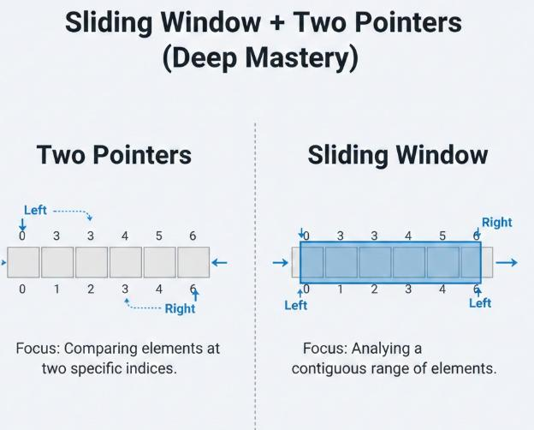
Type 3: Sliding window
The two pointers define a continuous section of an array or string. The window expands or shrinks based on a condition.
Examples:
- Longest substring without repeating characters
- Longest subarray satisfying a constraint
- Minimum-size subarray with a target sum
- Maximum sum of a subarray of size k
Sliding window is commonly considered a specialized form of the two-pointer technique.

4. Problems you can solve using two pointers
Here is a useful practice list for competitive programming.
No. | Problem | Typical approach
1 | Reverse an array | Opposite direction
2 | Check palindrome string | Opposite direction
3 | Two Sum in sorted array | Opposite direction
4 | Move zeros to the end | Same direction
5 | Remove duplicates from sorted array | Same direction
6 | Merge two sorted arrays | Same direction
7 | Find intersection of sorted arrays | Same direction
8 | Check if a pair with a given sum exists | Opposite direction
9 | Find a triplet with a target sum (3Sum) | Sorting + two pointers
10 | Container With Most Water | Opposite direction
11 | Find the maximum area between vertical lines | Opposite direction
12 | Longest substring without repeating characters | Sliding window
13 | Minimum-size subarray with sum at least K | Sliding window; positive numbers
14 | Remove a particular value in-place | Same direction
15 | Find pairs with a given difference in a sorted array | Two pointers

5. Two pointers vs. nested loops
Suppose we need to find two numbers with sum 10 in a sorted array of \(n\) elements.
Method | Time complexity | Extra space
Nested loops | (O(n^2)) | (O(1))
Two pointers | (O(n)) | (O(1))
The two-pointer method works in linear time because each pointer moves in only one direction and never needs to return to a previously visited position.

6. How to recognize a two-pointer problem
Look for these clues in a problem statement:
- You need to find a pair that satisfies a condition.
- The array is sorted, or sorting is allowed.
- You need to reverse or compare elements from both ends.
- You need to modify an array in-place, such as moving zeros or removing duplicates.
- You need to process two sorted arrays together.
- You need to find a continuous subarray or substring that satisfies a condition.
One caution: not every pair problem can be solved efficiently with two pointers. For example, finding a pair in an unsorted array without sorting may be easier with hashing.

